Before vibe code implementation for C# with Java:

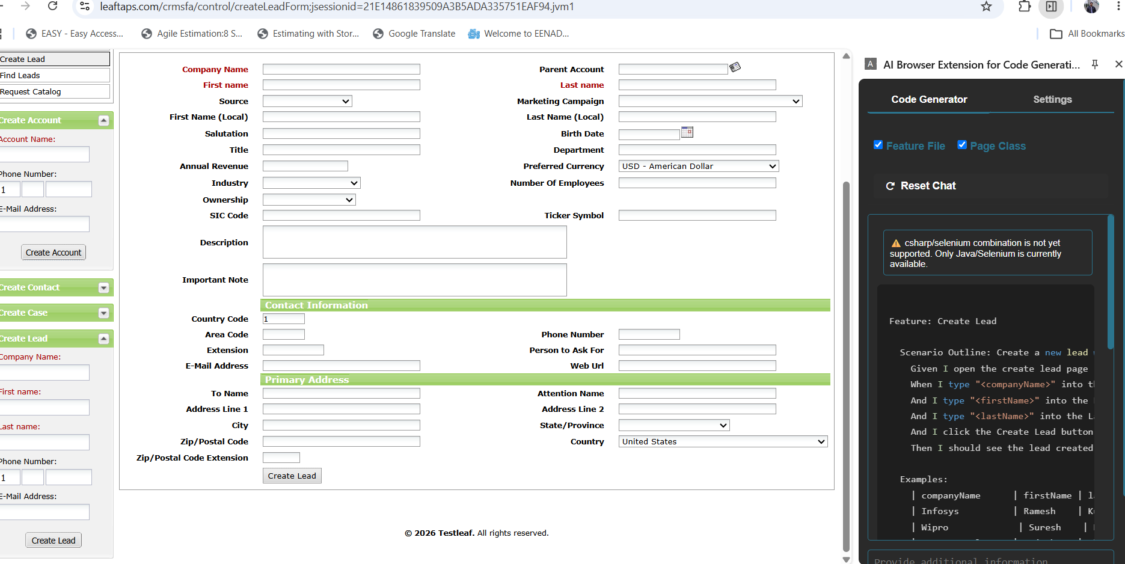

After vibe code implementation for C# with Java :

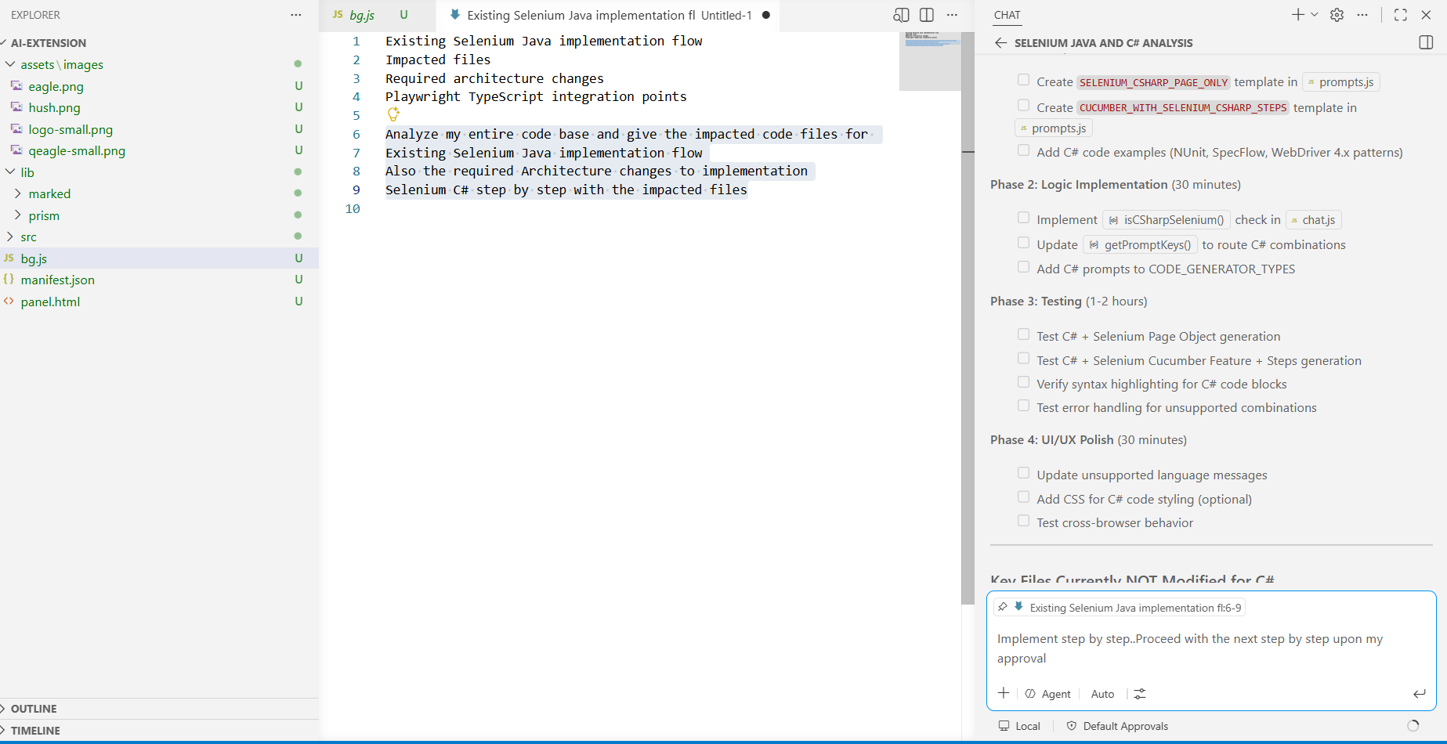

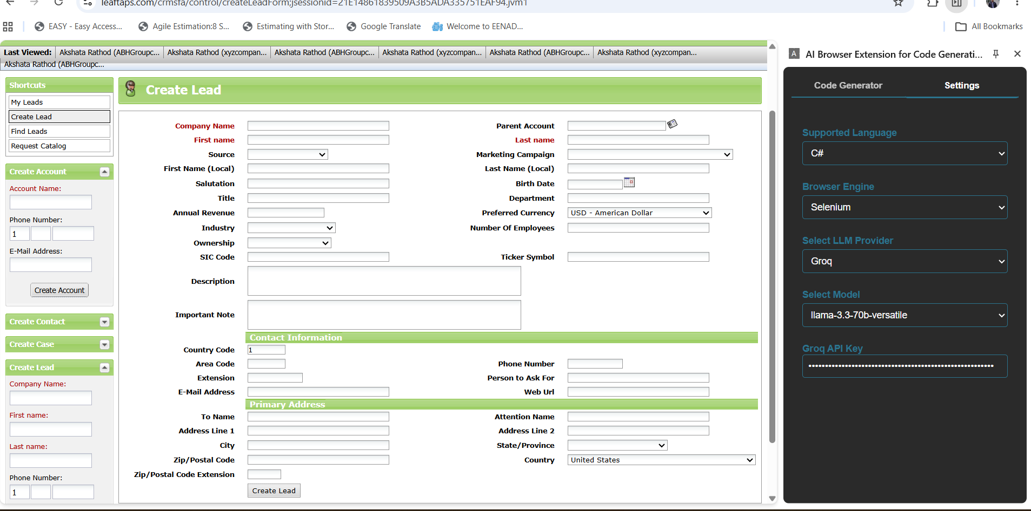

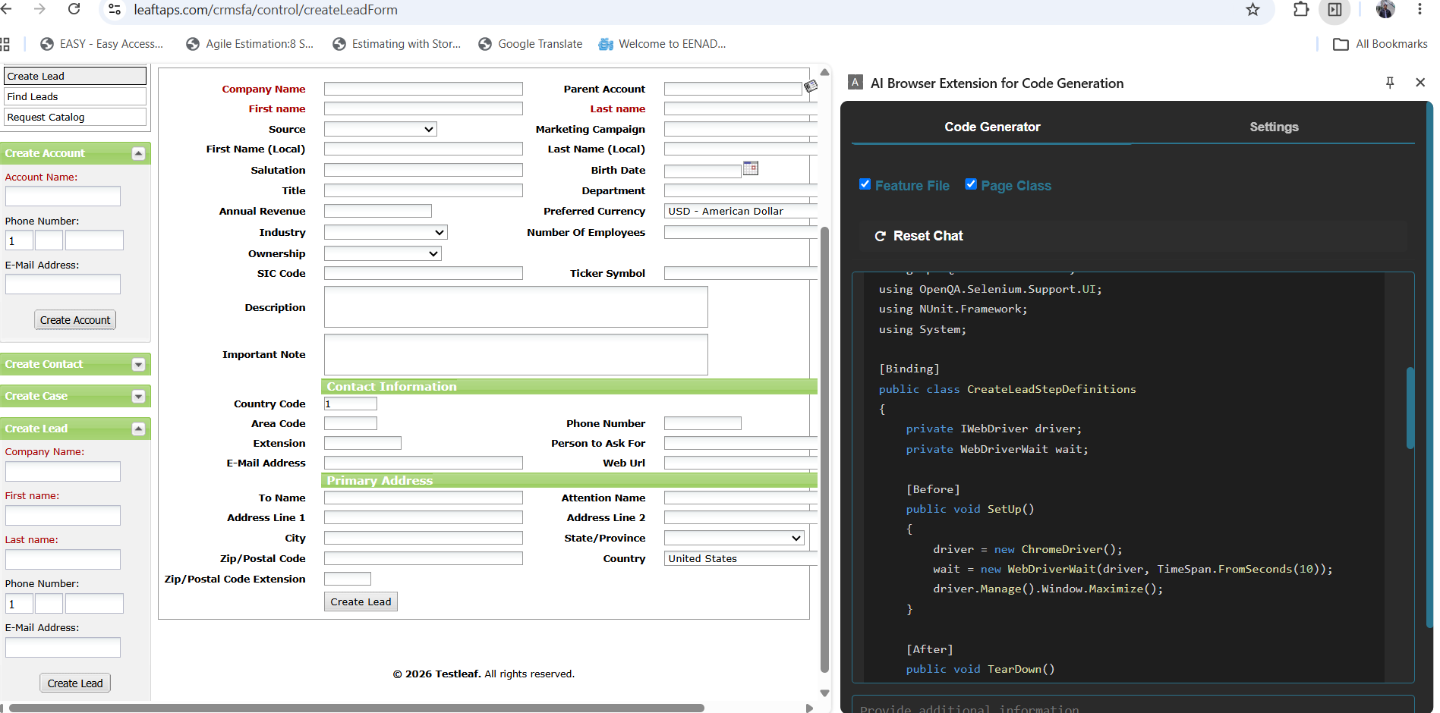

Feature: Create Lead

Scenario Outline: Successful creation of lead with valid data
Given I open the create lead page
When I type "<companyName>" into the Company Name field
And I type "<firstName>" into the First Name field
And I type "<lastName>" into the Last Name field
And I click the Create Lead button
Then I should see the created lead details

Examples:
| companyName | firstName | lastName |
| "TCS" | "Rahul" | "Kumar" |
| "Infosys" | "Suresh" | "Rao" |
| "Wipro" | "Rajesh" | "Sharma" |

using TechTalk.SpecFlow;
using OpenQA.Selenium;
using OpenQA.Selenium.Chrome;
using OpenQA.Selenium.Support.UI;
using NUnit.Framework;
using System;

[Binding]
public class CreateLeadStepDefinitions
{
private IWebDriver driver;
private WebDriverWait wait;

[Before]
public void SetUp()
{
driver = new ChromeDriver();
wait = new WebDriverWait(driver, TimeSpan.FromSeconds(10));
driver.Manage().Window.Maximize();
}

[After]
public void TearDown()
{
if (driver != null)
{
driver.Quit();
}
}

[Given(@"I open the create lead page")]
public void OpenCreateLeadPage()
{
driver.Navigate().GoToUrl("https://leaftaps.com/crmsfa/control/createLeadForm");
}

[When(@"I type ""(.*)"" into the Company Name field")]
public void EnterCompanyName(string companyName)
{
IWebElement companyNameField = wait.Until(
SeleniumExtras.WaitHelpers.ExpectedConditions.ElementToBeClickable(By.Id("createLeadForm_companyName"))
);
companyNameField.SendKeys(companyName);
}

[When(@"I type ""(.*)"" into the First Name field")]
public void EnterFirstName(string firstName)
{
IWebElement firstNameField = wait.Until(
SeleniumExtras.WaitHelpers.ExpectedConditions.ElementToBeClickable(By.Id("createLeadForm_firstName"))
);
firstNameField.SendKeys(firstName);
}

[When(@"I type ""(.*)"" into the Last Name field")]
public void EnterLastName(string lastName)
{
IWebElement lastNameField = wait.Until(
SeleniumExtras.WaitHelpers.ExpectedConditions.ElementToBeClickable(By.Id("createLeadForm_lastName"))
);
lastNameField.SendKeys(lastName);
}

[When(@"I click the Create Lead button")]
public void ClickCreateLeadButton()
{
driver.FindElement(By.Id("ext-gen548")).Click();
}

[Then(@"I should see the created lead details")]
public void VerifyLeadCreation()
{
// Add verification logic here
// For example, you can verify the presence of a specific element or text
IWebElement leadDetails = wait.Until(
SeleniumExtras.WaitHelpers.ExpectedConditions.VisibilityOfAllElementsLocatedBy(By.ClassName("sectionHeader"))
);
Assert.That(leadDetails.Displayed, Is.True);
}
}

Vibe coding to generate feature file with Playwright with TypeScript:

Before vibe code Implementation:

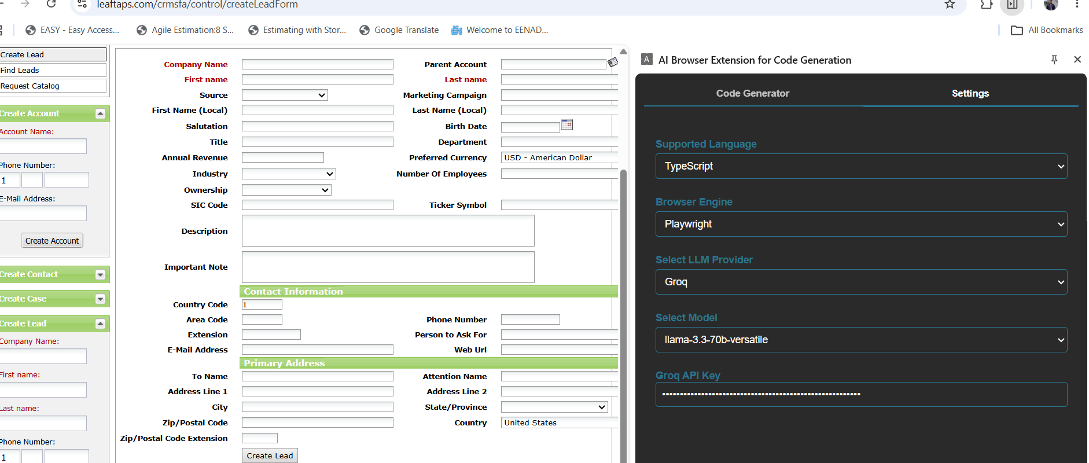

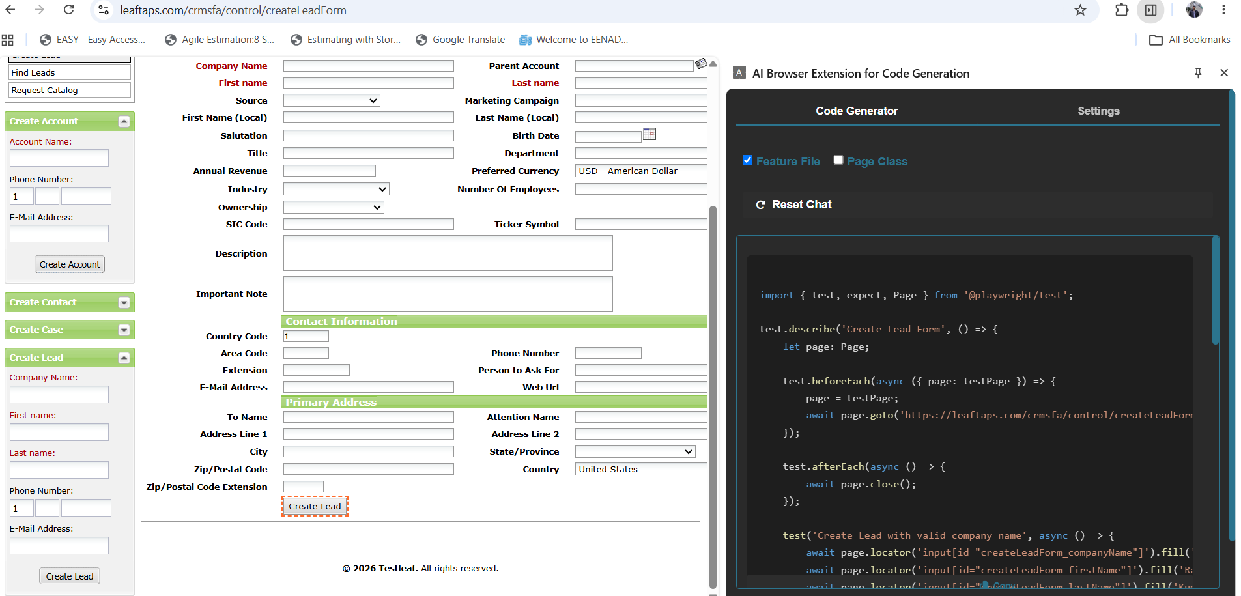

After vide code implementation:
